Validation and Verification Plan

Doc. Number: <<>>

Issue: 1.0
Compiled | Checked | Office of Airworthiness | Date
NAME:  James Lawson | SIGNED: | SIGNED:

Issue Record
Issue | Reason for Change | Date
1.0 | Initial Issue. | dd/mm/yyyy

Note: This document is updated as a complete document and not as individual pages.

Contents
Issue Record 2
Contents 3
Abbreviations 4
References 4
1 Introduction 5
2 Scope 5
3 Requirements 7
3.1 General 7
3.2 Requirements Structure 7
3.3 Requirements Set 2
3.4 Functional Development Assurance Levels 2
4 Validation 2
4.1 Validation PROCESS 2
4.2 Validation Methods 4
4.3 Validation Methodology Selection 6
4.4 Validation Artifacts 6
4.5 Validation ARTIFACTS 7
4.6 Validation Checklist 7
4.7 Change Control 8
5 Verification 8
5.1 Verification PROCESS 8
5.2 Verification Methods 10
5.3 Verification ArtifactS 13
5.4 Change Control 13
6 V&V Life Cycle 14
6.1 General 14
6.2 CoDR Deliverables 14
6.3 SRR Deliverables 14
6.4 PDR Deliverables 15
6.5 CDR Deliverables 15
6.6 FFRR Deliverables 16
6.7 TC Deliverables 17
7 Templates and Checklists 17
7.1 Validation Matrix Template 17
7.2 Validation Checklist 17
7.3 Verification Matrix Template 19

Abbreviations
AGS | Aircraft General Spares
CAA | Civil Aviation Authority
DO | Design Organisation
DOA | Design Organisation Approval
DOP | Design Organisation Procedure
ECR | Engineering Change Request
TC | Type Certificate
STC | Supplemental Type Certificate
ZA | <<company>>

References
Ref. | Document Number and Title | Issue | Date
 |  |  | dd/mm/yyyy
 |  |  | dd/mm/yyyy
 |  |  | dd/mm/yyyy

Introduction
Through the engineering lifecycle it is paramount that a well-defined design assurance process ensuring the integrity of the product under development is implemented. AC 25.174 recognizes SAE ARP4754A as an acceptable practice for a design assurance process for civil aircraft (14 CFR Parts 23, 27, 29, 33, and 35) and systems. The V&V of requirements are two key elements of the design assurance process.
As shown by Figure 1-1, the foundation of the process is the requirements. The requirements define the performance, functional, physical, interfaces, environmental, reliability, maintainability and safety aspects of the product under development i.e. “the what the design should be.” It is therefore essential to ensure that the requirements at all levels (aircraft, system and sub-system) have been validated and are correct and complete. This is achieved through a validation process, thus assuring the integrity of the product.
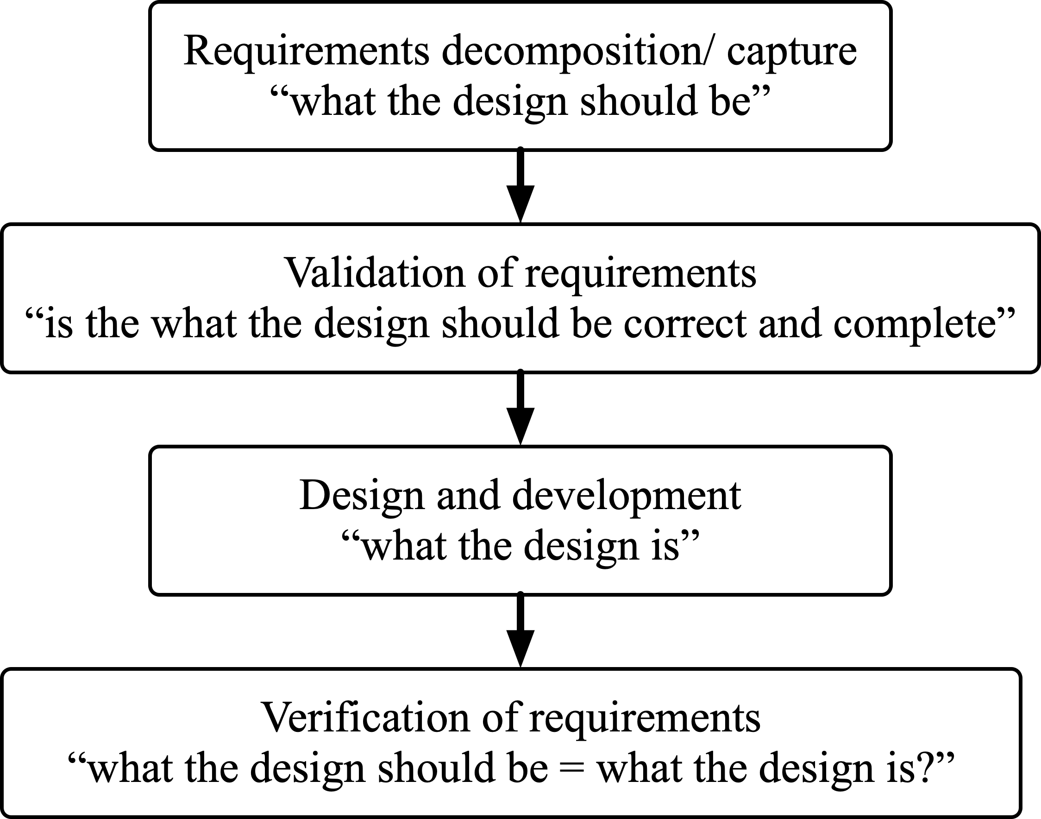
Figure 1-1 Design Assurance Process
Following the design and development effort, the requirements are verified via a verification process. The purpose of the verification process is to ensure that the requirements have been implemented adequately by the design. The verification process must prove that “what the design is” is the same as “what the design should be.”

Scope
This document describes the verification and validation efforts at all levels of system and sub-system requirements. These efforts work hand in hand with the development of safety artifacts (see Figure 2-1). The safety artifacts for civil aircraft are generated in accordance with SAE ARP4761 and can also be used for military aircraft. The lower-level V&V effort (e.g. software and complex hardware etc.), should be conducted as a direct result of system/ sub-system level V&V. The lower-level guidance includes the following standards: RTCA DO-178C and RTCA DO-254. Supplier V&V effort should be reviewed for equivalence to SAE ARP4761 and/ or this plan.
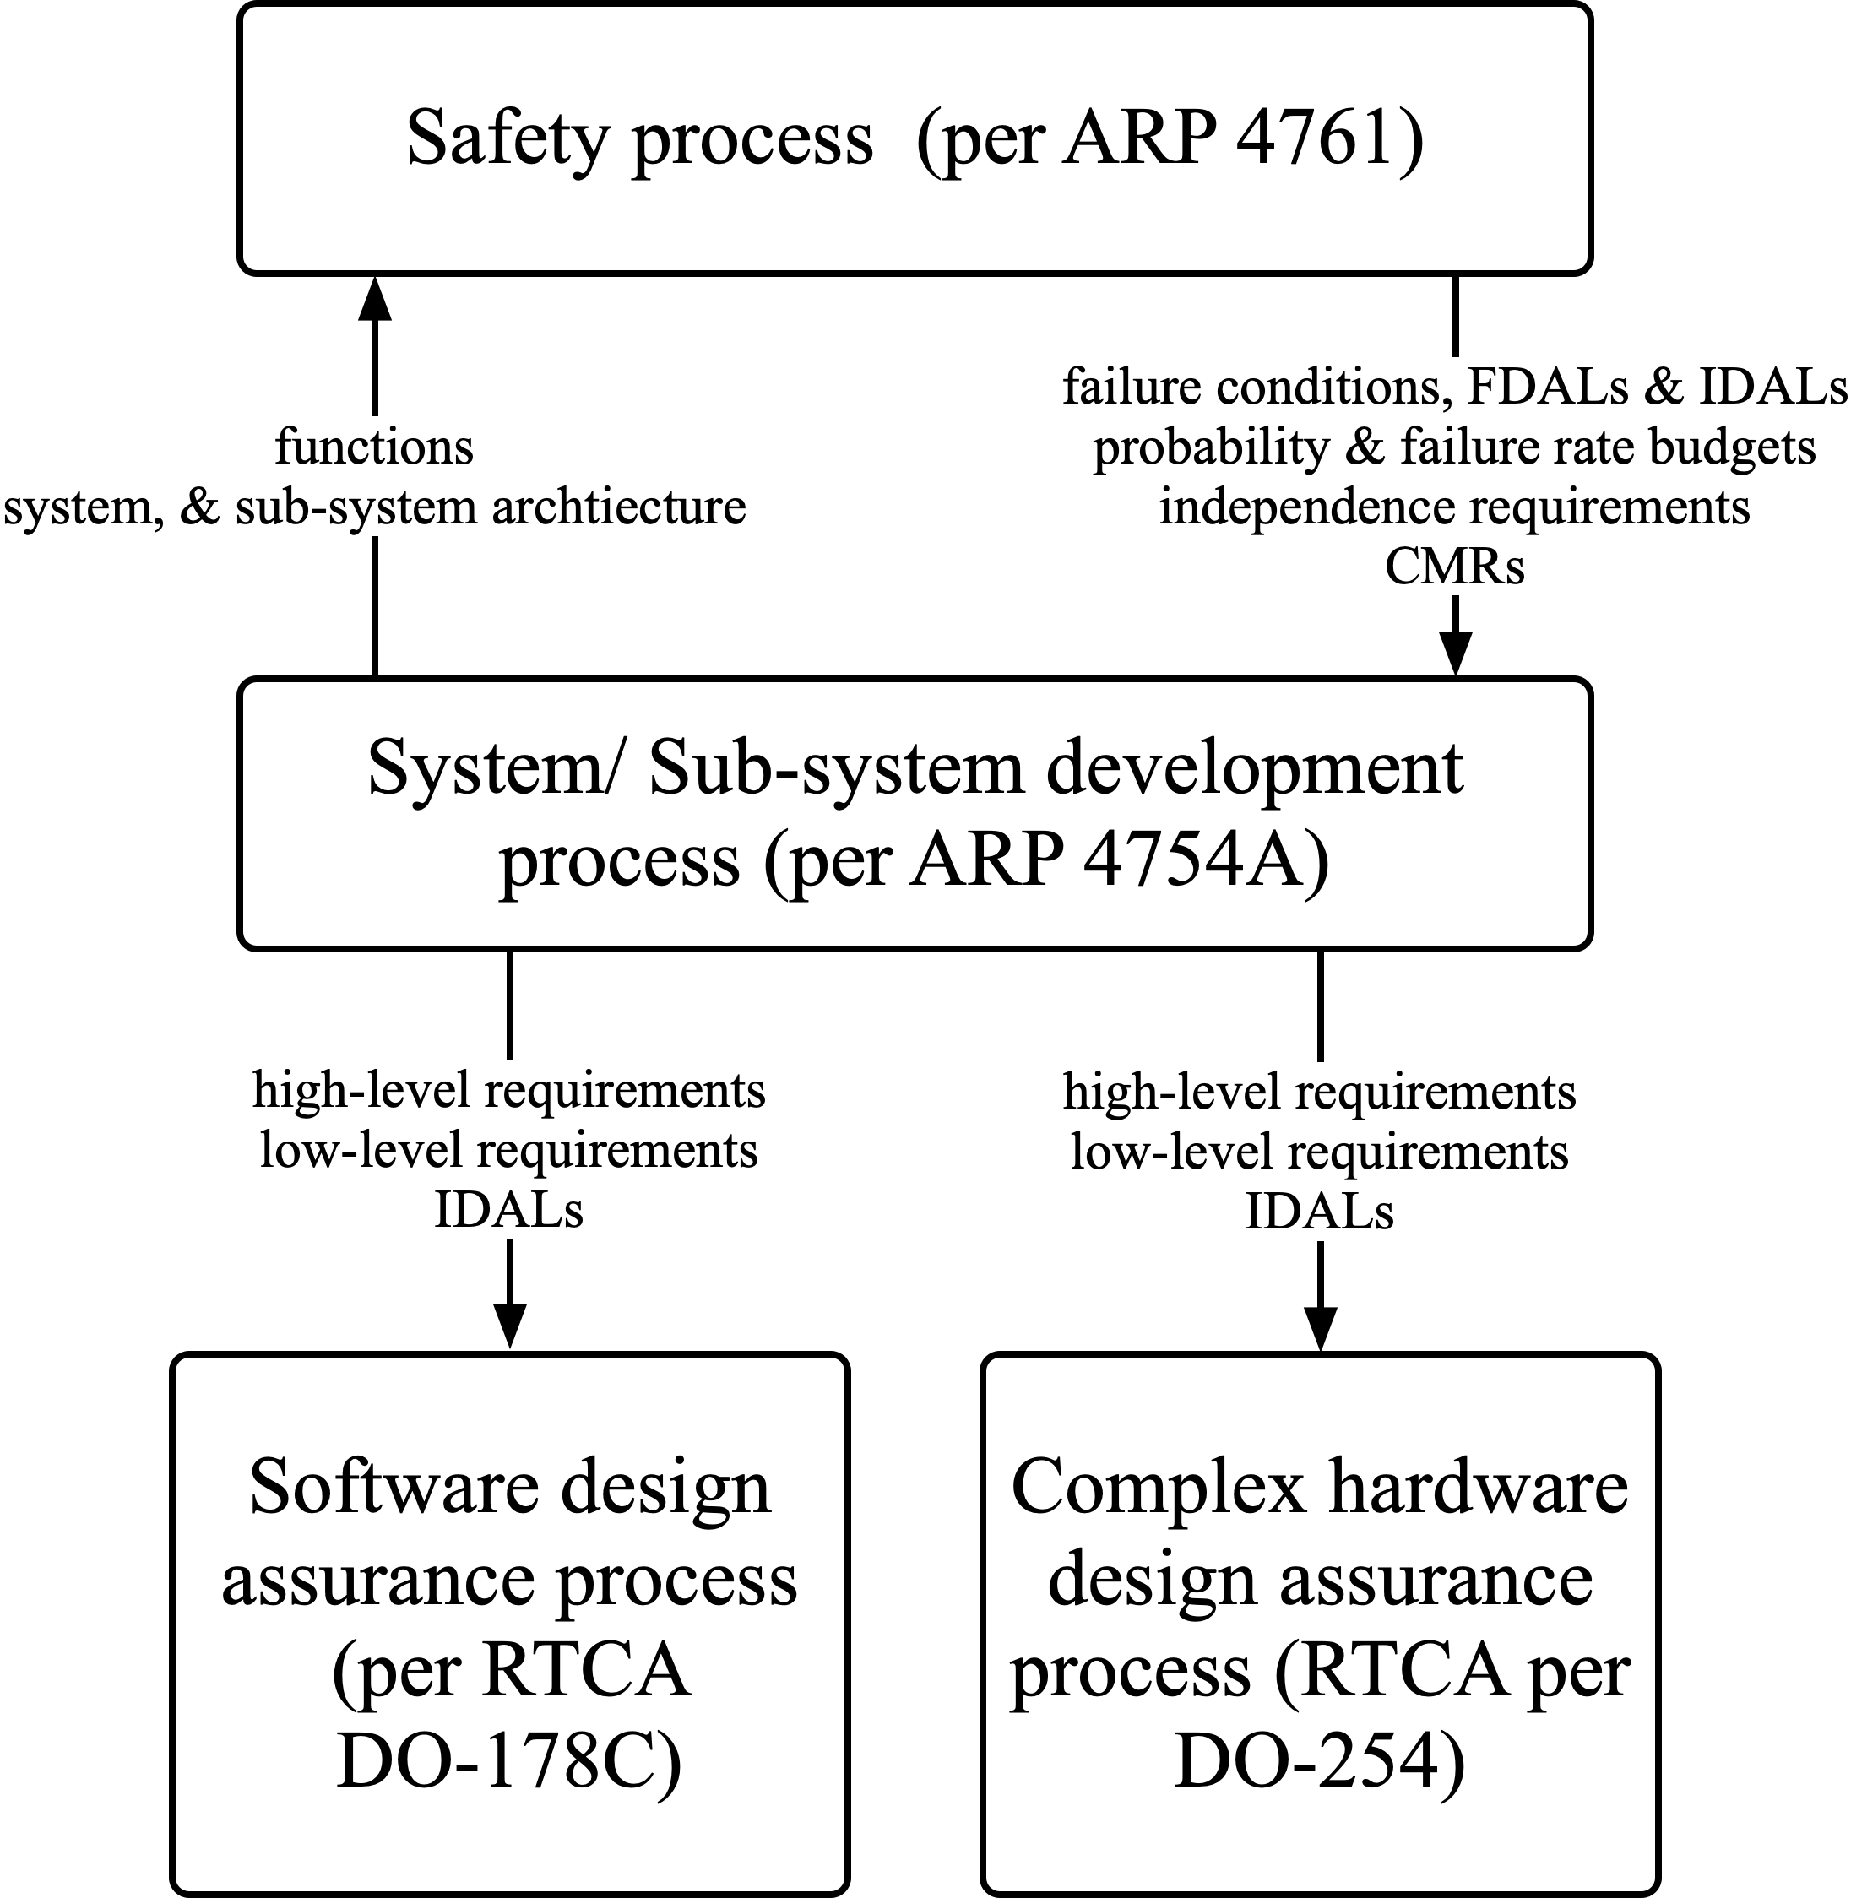
Figure 2-1 V&V Development Process
The V&V (Figure 2-1) processes are consistent with the classical “V diagram” that is a fundamental part of the aircraft and system development process (Figure 2-2). The left “leg” of Figure 2-2 is the validation process; flowing top down, while the right “leg” of Figure 2-2 is the verification process; flowing bottom up.
As shown in Figure 1-1 and Figure 2-2 and as per AC20-174, V&V are part of the certification process for civil aircraft. The V&V process are completed to comply with applicable regulations and special conditions, which are mainly:
- 14 CFR/CS/AWM 23.2500, 23.2505, 25.1301, 27.1301 and 29.130
- 14 CFR/CS/AWM 23.2510, 25.1309, 27.1309 and 29.1309
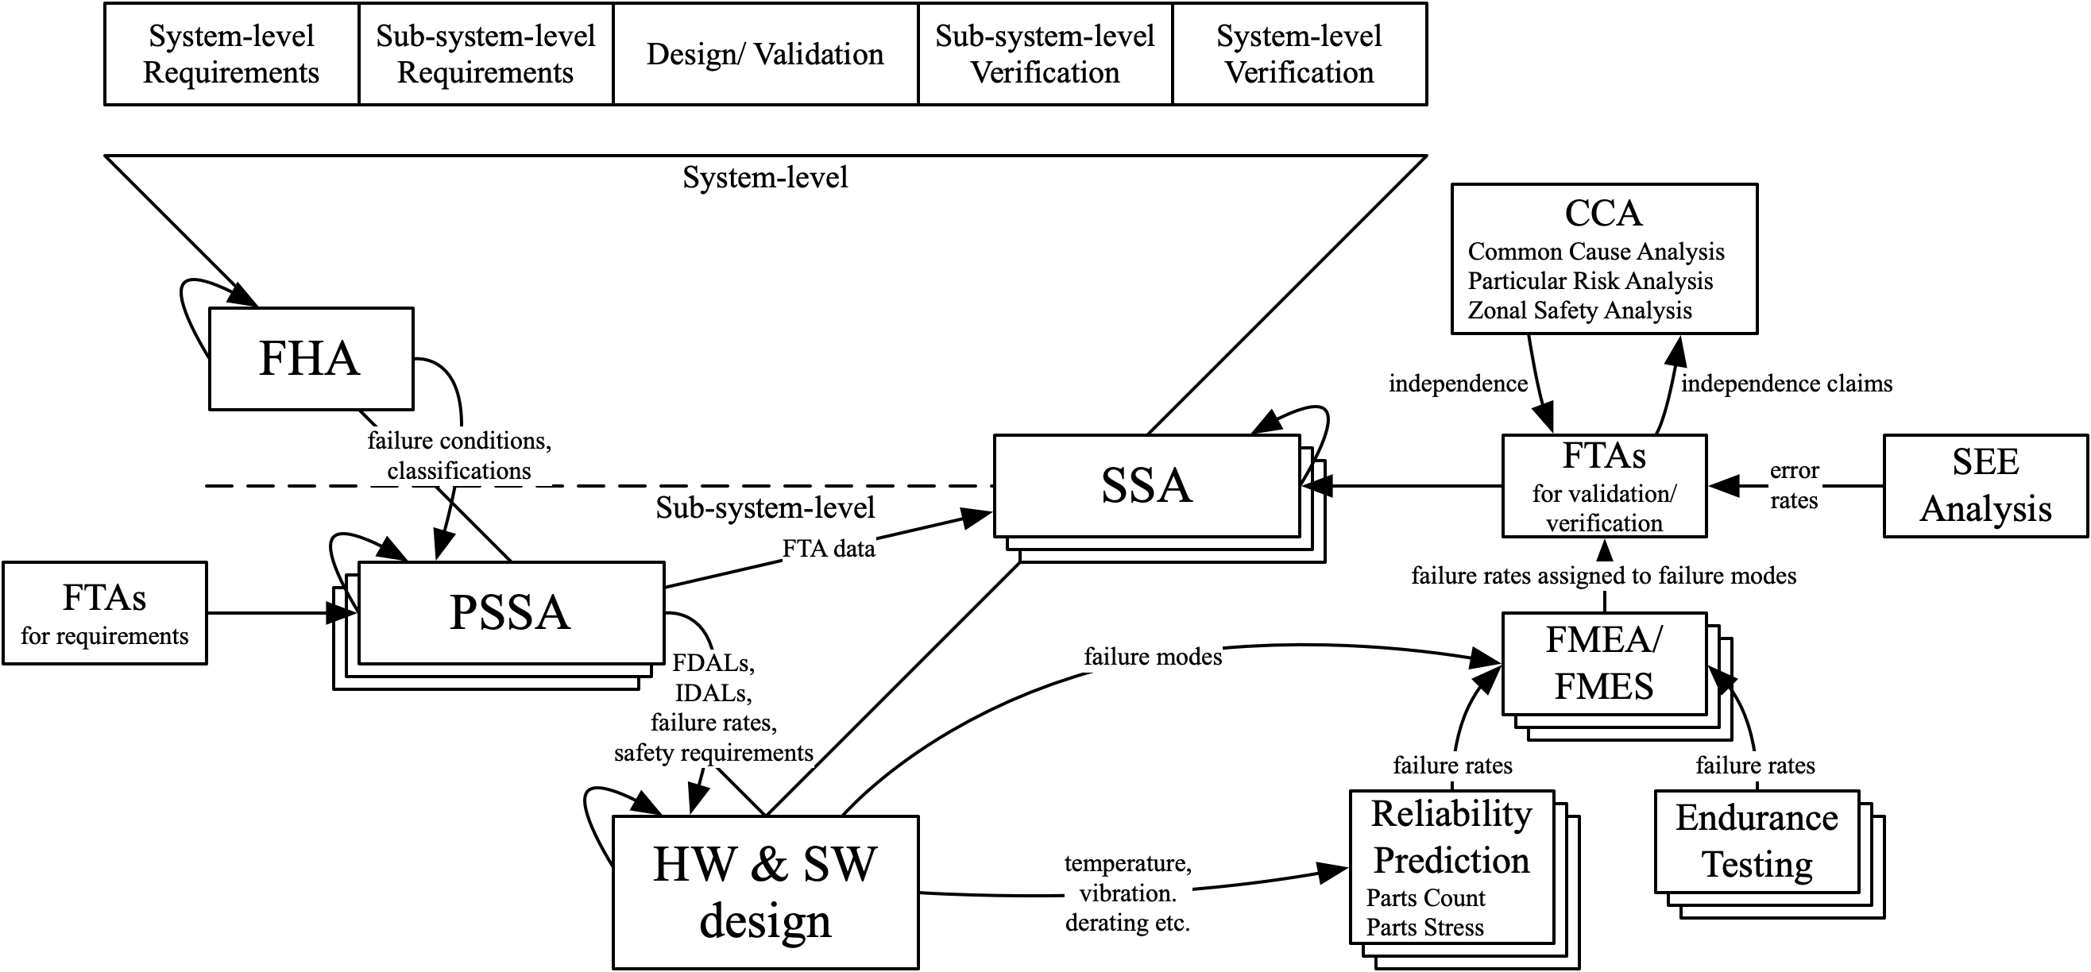
Figure 2-2 Systems & Safety Development Process
The systems and safety development process is defined by the Development Plan.

Requirements

General
As shown by Figure 1-1, the foundation of the V&V process is the requirements. To ensure the integrity of the requirements, they are drafted by engineers whom are subject matter experts. The first round of requirements may be undefined and marked as “TBD” or “TBR.” It is therefore essential to assign the appropriate validation artifact, as part of the validation process. The validation artifact is the evidence that captures the engineering work performed to substantiate or decompose the requirement i.e. remove the “TBD” or “TBR.”
As the requirements are decomposed, a key step is to review that all the lower-level requirements generated in their entirety, will enable the higher-level requirements to be satisfied.

Requirements Structure
The requirements are defined at multiple levels and degrees of detail. They are decomposed or captured in a top-down manner, starting at the system level. Each lower-level requirements flows down from an upper-level requirement or is a derived requirement. Each derived requirement must have a written rationale giving the reason for its existence.
The number of levels of requirements may vary from program to program. The aim should be to maintain the least number of levels that are practically possible, without compromising design assurance. Since each level of requirements needs to be validated and verified, more levels of requirements will result in additional V&V effort.
Figure 3-1 shows the requirements structure for the <<company>> parallel hybrid-electric powertrain.
<<TBD>>
Figure 3-1 Requirements Structure

Requirements Set
The requirements set (at each level) must be correct and complete, considering the following aspects, but not limited to:
- Requirements decomposed from regulations and special conditions
- Requirements decomposed from standards
- Requirements decomposed from aircraft/ system key performance parameters
- System architecture requirements
- Structural requirements e.g. limit/ ultimate static loads, vibration & fatigue
- Performance
- Functional requirements (including human factors)
- Physical requirements e.g size and weight
- Interfaces
- Environmental requirements e.g. RTCA-DO-160
- Reliability, maintainability, safety and security requirements (including FDAL/ IDAL and probability or failure rate budget and cycle time)
- Installation (spatial envelope, etc.)
- Software i.e. RTCA DO-178C requirements
- Complex hardware i.e. RTCA DO-178C requirements

Functional Development Assurance Levels
Functional Development Assurance Levels (FDALs) are assigned to system and sub-system level functions in accordance with SAE ARP4754A and SAE ARP4761. For each requirement, the V&V method is selected based on FDAL. Also, the IDAL which determines the appropriate RTCA DO-178C and RTCA DO-254 objectives is selected based on the FDAL. IDALs will be assigned to individual software and complex hardware configuration items. FDALs will be assigned at the system or subsystem level to enable the selection of common V&V methods across all the requirements of a particular system/ sub-system/ component. The V&V methods selected will be commensurate with the most severe FDAL for a particular system/ sub-system/ component.

Validation

Validation PROCESS
The validation process should result in the following:
- Definition and completion of a validation checklist
- Population of validation methods
- Creation of validation artifacts
- The application of requirements change control throughout the validation process
- Creation of a validation matrix
- A summary report capturing
  - Deviations from the Validation Plan
  - The system/ sub-system FDAL applied
  - Validation matrix
  - Validation artifacts
  - A validation coverage summary
All the requirements should be validated in accordance with this plan to ensure at each level, each requirement is correct and complete (Figure 4-1). At each level, a validation matrix is created for each set of requirements.
See the Development Plan which dictates where process independence is required i.e. the validation activity is performed by a person(s) other than the developer of the system, sub-system or configuration item.
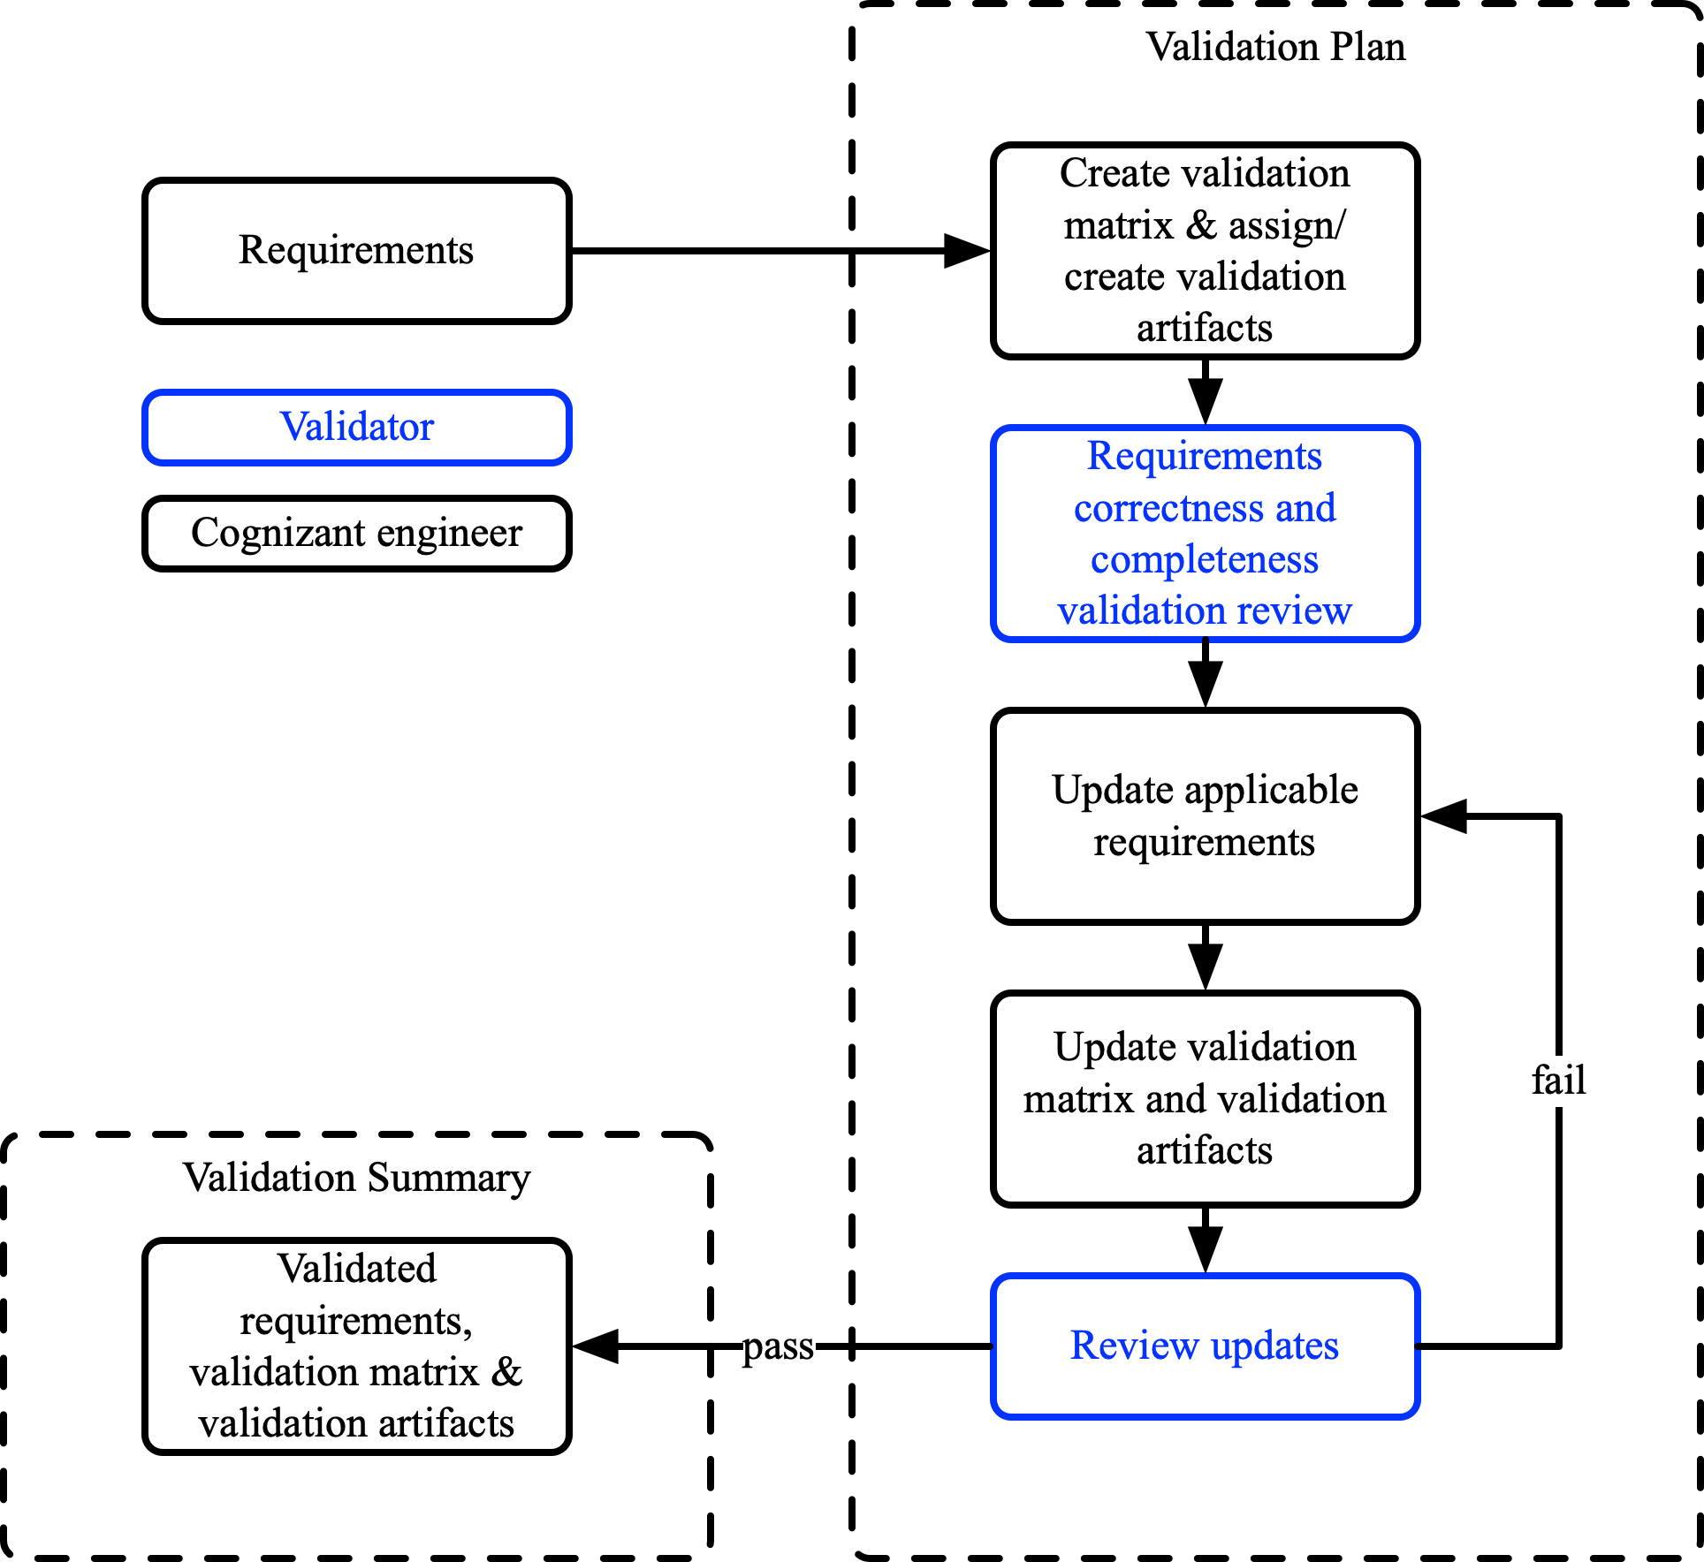
Figure 4-1: Validation Process
The validation process in Figure 4-1 is as follows:
Step 1 At each level, the cognizant engineer decomposes and captures an initial set of requirements.
Step 2 The cognizant engineer generates the initial validation matrix for each set of requirements, at each level, as per the format in Table 7-1. The applicable method(s) of validation are assigned for each requirement. A requirement may have multiple methods of validation. The applicable validation artifact(s) are also created and assigned. A requirement may have multiple validation artifacts.
Step 3 The initial set of requirements, validation matrix and validation artifacts are reviewed by the validator for correctness and completeness, as per Table 7-2 and Table 7-3 respectively. If process independence is dictated by the Development Plan, the validator is an independent engineer who was not involved in generating the requirements, validation matrix or validation artifacts but is a subject matter expert.
Step 4 The cognizant engineer updates the applicable requirements in accordance with the findings of the validator.
Step 5 The cognizant engineer updates the validation matrix and validation artifacts in accordance with the findings of the validator.
Step 6 The validator reviews the updated set of requirements, validation matrix and validation artifacts for completeness and correctness to ensure that the previous review findings have been addressed satisfactorily. If the validator has further findings, Steps 4, 5 and 6 are repeated. The validator will make the final determination of the validation status of each requirement. If a requirement is part of a release, it should be satisfactorily validated prior to that release.
Step 7 If the validator has no further findings, validation is achieved and the validated set of requirements, validation matrix and validation artifacts are issued by the cognizant engineer.
Suppliers should validate the requirements that are flowed down to them in accordance with the <<company>> process or a supplier process that is equivalent. If the supplier intends to use an alternate process, it will be audited and must be approved by <<company>>.

Validation Methods

GENERAL
The following validation methods, should be used for the validation of each requirement:
- Calculations/ Analysis
- Certification
- Design/ Data Review
- Safety Analysis
- Similarity of Service Experience (from previously certified systems)
- Simulation
- Test

CERTIFICATION
The method of validation is certification if the requirement is a certification requirement due to a regulation, special condition or any other certification requirement.
NOTE: The certification requirements will populate the compliance matrix of Certification Plan(s).

CALCULATIONS/ ANALYSIS
The method of validation is calculations/ analysis if the correctness and completeness of the requirement is defined or substantiated by means of calculations/ analysis. The calculations/ analysis can be either quantitative or qualitative. If calculations/ analysis is assigned as a method of validation, then a validation artifact must be specified.
NOTE: This analysis is not for verification but to define or substantiate the requirement.

DESIGN/ DATA REVIEW
The method of validation is design/ data review if the correctness and completeness of the requirement is determined by means of design/ data review by a subject matter expert. If applicable, this includes identifying the associated assumptions.

SAFETY ANALYSIS
The method of validation of the requirement is the Preliminary System Safety Assessment (PSSA). The PSSA must be specified as a validation artifact.

SIMILARITY OF SERVICE EXPERIENCE
The method of validation is similarity of experience if the correctness and completeness of the requirement is defined or substantiated by means of similarity of experience as part of a similar airborne application.

SIMULATION
The method of validation is simulation if the correctness and completeness of the requirement is defined or substantiated by means of simulation including static or dynamic modelling. The simulation itself may require validation via testing. If simulation is assigned as a method of validation, then a validation artifact must be specified.
NOTE: This simulation is not for verification but to define or substantiate the requirement.

TEST
The method of validation is test if the correctness and completeness of the requirement is defined or substantiated by means of testing. If test is assigned as a method of validation, then a validation artifact must be specified.
NOTE: This test is not for verification but to define or substantiate the requirement.

Validation Methodology Selection
The validation methods should be selected based on the severity of the FDAL. Exceptions can be made, but the general recommendations, as per SAE ARP4754A are shown in Table 4-1.
Methods and Data | FDAL
 | A and B | C | D | E
Validation Matrix | Y | Y | N | N
Validation Plan | Y | Y | N | N
Validation Summary | Y | Y | N | N
Requirements Traceability (non-derived requirements) | Y | Y | N | N
Requirements Rationale (derived requirements) | Y | Y | N | N
Calculations/ Analysis | Y (one or more plus Similarity of Service Experience if available) | Y (one or more) | N | N
Design/ Data Review |  |  | N | N
Simulation |  |  | N | N
Test |  |  | N | N
Certification |  |  | N | N
Similarity of Service Experience |  |  | N | N
Safety Analysis | Y | Y | N | N
Table 4-1: Validation Method Selection
NOTE:
Y Required for a particular system/ sub-system as dictated by the FDAL for that system/ sub-system
N Not required for a particular system/ sub-system as dictated by the FDAL for that system/ sub-system

Validation Artifacts
The validation artifacts are the evidence that captures the engineering work performed to substantiate or decompose the requirement i.e. remove the “TBD” or “TBR.” A validation artifact must be assigned to all requirements where the method of validation is simulation, design/ data review, calculations/ analysis or safety analysis.

Validation ARTIFACTS

GENERAL
The drafting and validation of requirements is a highly iterative process throughout the development of the aircraft and/ or systems. The initial validation of requirements should be completed before the suppliers are engaged. The validation of requirements, at all levels, will occur iteratively and concurrent with their decomposition and capture.

Validation Matrix
The validation matrix, as per the format in Table 7-1, is a table containing the following columns:
- Unique identifier of the requirement.
- Requirement description
- Upper Requirement
- Lower Requirement
- Method of Validation.
NOTE: A requirement may have more than one means of validation.
- Validation Artifact
NOTE 1: The verification artifacts will be used as compliance artifacts to avoid duplication of documents and work.
- Validation Status
The Status in the validation matrix can be one of the following:
Not Validated Which means that the validation has not yet been conducted.
Valid Which means that the validation has been completed and the requirement is valid.
Unvalidatable Which means that the validation activities of the requirement have been conducted but validation has not been achieved.

Validation Checklist
As part of the validation, each requirement should be checked against the criteria listed in Table 7-2 and Table 7-3.

Change Control
When a requirement has changed, the status in the validation matrix must change to “not validated.” Furthermore, the method of validation and validation artifacts should be reviewed to determine whether they need to be updated. Then, if it is necessary, updated accordingly.
Similarly, if the validation artifacts change, the method of validation should be reviewed to determine whether it needs to be updated. Then, if it is necessary, updated accordingly.
The change process is defined in more detail by the Configuration Management Plan.

Verification

Verification PROCESS
The verification process should result in the following:
- Population of verification methods
- Creation of verification artifacts i.e. test plans, procedures and results or results of a simulation or analysis
- The application of requirements change control throughout the verification process
- Creation of a verification matrix
- A summary report capturing
  - Deviations from the Verification Plan
  - The system/ sub-system FDAL applied
  - A description of any open problem reports/ associated impact on safety
  - Verification matrix
  - Verification artifacts
  - A verification coverage summary
All the requirements should be verified in accordance with this plan to ensure that, at each level, the requirements have been implemented adequately by the design (Figure 5-1). At each level, a verification matrix is created for each set of requirements.
See the Development Plan which dictates where process independence is required i.e. the verification activity is performed by a person(s) other than the developer of the system, sub-system or configuration item.
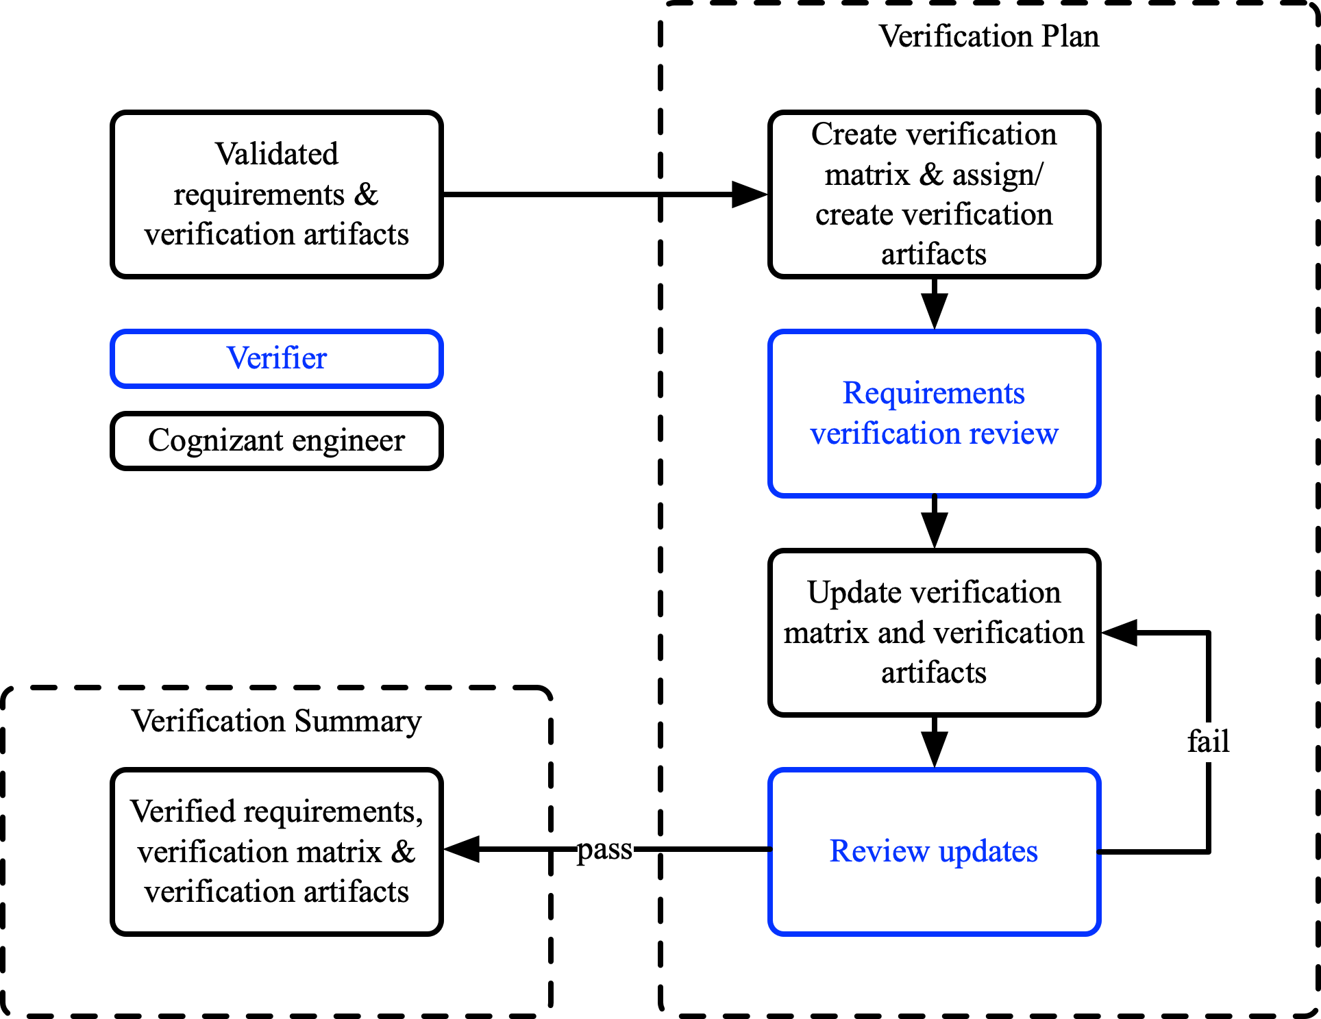
Figure 5-1: Verification Process
The verification process in Figure 4-1 is as follows:
Step 1 The cognizant engineer generates the initial verification matrix for each set of requirements, at each level, as per the format in Table 7-4. The applicable method(s) of verification are assigned for each requirement. A requirement may have multiple methods of verification. The applicable verification artifact(s) are also created and assigned. A requirement may have multiple verification artifacts.
Step 2 The initial verification matrix and verification artifacts are reviewed by the verifier. If process independence is dictated by the Development Plan, the validator is an independent engineer who was not involved in generating the requirements, validation matrix or validation artifacts but is a subject matter expert.
Step 3 The cognizant engineer updates the verification matrix and verification artifacts in accordance with the findings of the verifier.
Step 4 The verifier reviews the updated verification matrix and verification artifacts to ensure that the previous review findings have been addressed satisfactorily. If the verifier has further findings, Steps 3 and 4 are repeated. The verifier will make the final determination of the verification status of each requirement. If a requirement is part of a release, it should be satisfactorily verified prior to that release.
Step 5 If the verifier has no further findings, verification is achieved and the verification matrix and verification artifacts are issued by the cognizant engineer.
Suppliers should verify the requirements that are flowed down to them in accordance with the <<company>> process or a supplier process that is equivalent. If the supplier intends to use an alternate process, it will be audited and must be approved by <<company>>.

Verification Methods

GENERAL
The following verification methods, should be used for the verification of each requirement:
- Calculations/ Analysis
- Design/ Data Review
- Equipment Qualification
- Flight Test
- Ground Test
- Laboratory Test
- Functional Test
- Physical Inspection
- Safety Analysis
- Similarity of Service Experience (from previously certified systems)
- Simulation
NOTE: The methods of verification and the methods of compliances are identical.

CALCULATIONS/ ANALYSIS
The method of verification is calculations/ analysis if the requirement is verified by means of the results of calculations/ analysis including structural analysis. The calculations/ analysis can be either quantitative or qualitative. If calculations/ analysis is assigned as a method of verification, a report documenting the results must be specified.

DESIGN/ DATA REVIEW
The method of verification is design/ data review if the requirement is verified by means of the results of design/ data review by a subject matter expert. If applicable, this includes identifying the associated assumptions. The design description can be used to describe the implementation of requirements that are verified by design/ data review.

EQUIPMENT QUALIFICATION
The method of verification is equipment qualification if the requirement is verified by means of the results of equipment qualification including RTCA DO-160G environmental testing. If equipment qualification is assigned as a method of verification, a report documenting the results must be specified or a report documenting the similarity between the design and a design that has already been qualified.

FLIGHT TEST
The method of verification is flight test if the requirement is verified by means of flight test. If flight test is assigned as a method of validation, then a test plan, procedures and report must be listed as verification artifacts.

GROUND TEST
The method of verification is ground test if the requirement is verified by means of ground test. If ground test is assigned as a method of validation, then a test plan, procedures and report must be listed as verification artifacts.

LABORATORY TEST
The method of verification is laboratory test if the requirement is verified by means of laboratory test including rig test. If laboratory test is assigned as a method of validation, then a test plan, procedures and report must be listed as verification artifacts.

FUNCTIONAL TEST
The method of verification is functional test if the requirement is verified by means of functional test. If functional test is assigned as a method of validation, then a test plan, procedures and report must be listed as verification artifacts.
The functional test can be carried out as part of a laboratory including rig, ground or flight test and can be used to verify the following:
- System/ sub-system performs as intended under normal/ abnormal operating conditions
- System/ sub-system performs as intended in the event of a failure
- Unintended functions do not impact safety

PHYSICAL INSPECTION
The method of verification is physical inspection if the requirement is verified by means of physical inspection e.g size, weight, physical appearance and installation.

SAFETY ANALYSIS
The method of validation of the requirement is the System Safety Assessment (SSA). The SSA must be specified as a verification artifact.

SIMILARITY OF EXPERIENCE
The method of verification is similarity of experience if the requirement is verified by means of similarity of experience as part of a similar airborne application.

SIMULATION
The method of validation is simulation if the correctness and completeness of the requirement is defined or substantiated by means of simulation including static or dynamic modeling. The simulation itself may require validation via testing. If simulation is assigned as a method of validation, then a validation artifact must be specified.

VERIFICATION METHODOLOGY SELECTION
The Verification Methods should be selected based on the severity of the FDAL. Exceptions can be made, but the general recommendations, as per SAE ARP4754A are shown in Table 5-1.
Methods and Data | FDAL
 | A and B | C | D | E
Verification Matrix | Y | Y | Y | N
Verification Plan | Y | Y | Y | N
Verification Procedures | Y | Y | Y | N
Verification Summary | Y | Y | Y | N
Calculations/ Analysis (note 1) | Y (one of Equipment Qualification, Flight Test, Ground Test, Laboratory Test and one or more of others) | Y (one or more) | Y (one or more) | N
Design/ Data Review (note 1) |  |  |  | N
Equipment Qualification (note 1) |  |  |  | N
Flight Test (note 1) |  |  |  | N
Ground Test (note 1) |  |  |  | N
Laboratory Test (note 1) |  |  |  | N
Simulation |  |  |  | N
Functional Test | Y | Y | Y | Y
Physical Inspection | Y | Y | Y | Y (note 2)
Safety Analysis | Y | Y | Y | Y
Similarity of Service Experience | Y (if available) | N | N | N
Table 5-1: Verification Method Selection
NOTE:
Y Required for a particular system/ sub-system as dictated by the FDAL for that system/ sub-system
N Not required for a particular system/ sub-system as dictated by the FDAL for that system/ sub-system
NOTE 1: These methods provide similar degrees of verification. The selection of which methods will be most useful may depend on the specific system architecture or the specific function(s) implemented. RTCA-DO-178B/ED-12B and RTCA-DO-254/ED-80 define applicable tests for software and electronic hardware.
NOTE 2: As necessary to show installation and environmental compatibility.

Verification ArtifactS

GENERAL
The verification artifacts are the test plans, procedures and results, simulation and analysis. A verification artifact must be assigned to all requirements where the method of validation is any type of test, simulation, design/ data review, calculations/ analysis or safety analysis.

Verification Matrix
The verification matrix, as per the format in Table 7-4, is a table containing the following:
- Unique identifier of the requirement.
- Requirement description
- Method of Verification.
NOTE: A requirement may have more than one means of verification.
- Verification Artifact
NOTE 1: Both the test procedure and test report should be listed as verification artifacts for laboratory/ rig, aircraft ground and flight tests.
NOTE 2: The validation artifacts can be used as compliance artifacts to avoid duplication of documents and work.
- Verification Status
The Status in the verification matrix can be one of the following types:
Not Verified Which means that the verification has not yet been conducted.
Verified Which means that the verification has been completed and the requirement is verified.
Unverifiable Which means that the verification activities of the requirement have been conducted but verification has not been achieved.

Change Control
When a requirement has changed, the status in the verification matrix must change to “not verified.” Furthermore, the method of verification and verification artifacts should be reviewed to determine whether they need to be updated. Then, if it is necessary, updated accordingly.
Similarly, if the verification artifacts change, the method of verification should be reviewed to determine whether it needs to be updated. Then, if it is necessary, updated accordingly.
The change process is defined in more detail by the Configuration Management Plan.

V&V Life Cycle

General
Technical reviews at a minimum will be completed at the following major program milestones:
- Concept Design Review (CoDR)
- System Requirements Review (SRR)
- Preliminary Design Review (PDR)
- Critical Design Review (CDR)
- Test Readiness Review(s) (TRR)
- First Flight Readiness Review (FFRR)
- Type Inspection Review (TIR)
- Production Readiness Review (PRR)
The PDR and CDR are conducted at system and sub-system levels and by the supplier for the equipment provided.

CoDR Deliverables
The validation and verification deliverables, as well as other salient deliverables for CoDR, are the following:
- Draft system and sub-system requirements
- Concept feasibility and technology gaps

SRR Deliverables
The validation and verification deliverables, as well as other salient deliverables for SRR, are the following:
- Initial system and sub-system requirements
- Initial validation matrices
- Initial verification matrices
- Initial validation artifacts
- Preliminary FHA and PSSA
- Preliminary design description
- Completion of SRR hardware/ software prototyping activities to validate:
  - Requirements
  - Concept feasibility

PDR Deliverables
The validation and verification deliverables, as well as other salient deliverables for PDR, are the following:
- PDR updated system and sub-system requirements
- PDR updated validation matrices
- PDR updated verification matrices
- PDR updated validation artifacts
- PDR updated FHA and PSSA
- PDR updated design description
- Initial verification artifacts including:
  - Initial laboratory test plans
  - Initial rig test plans
  - Initial ground test plans
  - Initial flight test plans
- Completion of PDR hardware/ software development activities to validate:
  - Requirements
  - System architecture
  - Operation

CDR Deliverables
The validation and verification deliverables, as well as other salient deliverables for CDR, are the following:
- CDR updated validation matrices
- CDR updated verification matrices
- CDR updated validation artifacts
- CDR updated FHA and PSSA
- Initial SSA
- CDR updated design description
- CDR updated verification artifacts including:
  - CDR updated laboratory test plans/ procedures
  - CDR updated rig test plans/ procedures
  - CDR updated ground test plans/ procedures
  - CDR updated flight test plans/ procedures
- PDR updated system requirements
- PDR updated sub-system requirements
  - Decomposed into high level requirements (DO 178C level A – D)
  - Decomposed into high level requirements (DO 254 level A – D)
  - Further decomposed into low level requirements for software (DO 178C level A – C)
  - Further decomposed into low level requirements for complex hardware (DO 254 level A – C)
- Software plans/ standards
- Complex hardware plans/ standards
- CDR updated problem reports etc.
- CMRs
- Completion of CDR hardware/ software development activities to validate:
  - Requirements
  - System architecture
  - Operation

FFRR Deliverables
The validation and verification deliverables, as well as other salient deliverables for FFRR, are the following:
- SoF validation matrices
- SoF verification matrices
- SoF validation artifacts
- SoF FHA and PSSA
- SoF SSA
- SoF verification artifacts including:
  - SoF laboratory test plans/ procedures/ reports
  - SoF rig test plans/ procedures/ reports
  - SoF ground test plans/ procedures/ reports
  - SoF flight test plans/ procedures/ reports
  - SoF calculations/ analysis and results
  - SoF simulation results and reports
- SoF system requirements
- SoF sub-system requirements
- SoF software reports
- SoF complex hardware reports
- SoF updated problem reports etc.
- SoF inspection reports

TC Deliverables
The validation and verification deliverables, as well as other salient deliverables for TC, are the following:
- Final validation matrices
- Final verification matrices
- Final validation artifacts
- Final FHA and PSSA
- Final SSA
- Final verification artifacts including:
  - Final laboratory test reports
  - Final rig test reports
  - Final ground test reports
  - Final flight test reports
  - Final calculations/ analysis and results
  - Final simulation results and reports
- Final software reports/ accomplishment summary
- Final complex hardware reports/ accomplishment summary
- Final CMRs
- Final inspection reports

Templates and Checklists

Validation Matrix Template
Identifier | Requirement Description | Upper Requirement | Lower Requirement | Methods of Validation | Validation Artifact(s) | Validation Status
Table 7-1: Validation Matrix Template
If the requirement traces from an upper-level requirement, include the upper-level requirement number in the associated column. If the requirement traces to a lower-level requirement, then include the lower-level requirement number in the associated column. If it is a derived requirement, then include derived in this column.

Validation Checklist
# | Correctness Check
1 | The requirement should be complete with tolerances for qualitative/ performance values (e.g. less than, greater than or equal to, plus or minus, 3 sigma root sum squares).
2 | Where appropriate, do requirements trace to higher level documents?
3 | Where appropriate, do requirements trace to lower level documents?
4 | Are requirements stated as completely as possible? Have all incomplete requirements been captured as TBDs or TBRs and a complete listing of them maintained with the requirements?
5 | The use of “To Be Determined” (TBD) values should be minimized. It is better to use a best estimate for a value and mark it “To Be Resolved” (TBR) with assumptions(s) along with what must be done to eliminate the TBR, who is responsible for its elimination and by when it must be eliminated.
6 | Are structural requirements missing?
7 | Are installation requirements missing?
8 | Are manufacturability requirements missing?
9 | Are performance requirements missing?
10 | Are functional requirements (including human factors) missing?
11 | Are physical requirements missing e.g size and weight?
12 | Are interface requirements missing?
13 | Are environmental requirements missing?
14 | Are reliability, maintainability, safety and security requirements missing (including FDAL/ IDAL and probability or failure rate budget and cycle time)?
15 | Have the parent requirements been completely decomposed (including regulations, special conditions and standards)?
16 | Have all assumptions been explicitly stated?
17 | Do derived requirements have a rationale?
18 | Have validation means been defined?
19 | Have verification means been defined?
20 | Are key terms included in the project’s glossary?
21 | Have untraced requirements been reviewed for safety impact?
Table 7-2: Validation Correctness Checks
# | Completeness Check
1 | Is the requirement grammatically correct?
2 | Is terminology used consistently?
3 | Is the requirement a duplicate?
4 | Is the requirement free of typos, misspellings, and punctuation errors?
5 | Does the requirement comply with style rules?
6 | Is the requirement stated positively i.e. "shall" v. negatively i.e. “shall not?"
7 | Is there only one shall statement per requirement?
8 | Is the requirement in the proper section of the document?
9 | Use of Correct Terms:  Shall = requirement  Should = recommendation/ goal  Will = intention
10 | Requirements should be phrased in the active voice using the form “The <system> shall <XYZ>.”  Event-driven requirements:  In the event of <specific event> the <system name> shall <system response>.  Behavior driven requirements:  If <optional trigger>, then the <system name> shall <system response>.  Note: the <optional trigger> at the beginning or end of the requirement. Whether the beginning or the end is chosen should be consistent across all requirements.  State driven requirements:  While <entering, exiting or in a specific state (or mode)> the <system name> shall <system response>.
11 | A requirement must state “The system shall” (perform, provide or other verb) followed by a description of what must be performed or provided. The active voice requires that the entity performing the action is the subject of the sentence.  Often when the term "shall be" is used, the statement is in the passive voice.  Event-driven requirements:  When <optional precondition/trigger> the <system name> shall <system response>.  In the event of <specific event> the <system name> shall <system response>.  Behavior driven requirements:  If <optional precondition/trigger>, then the <system name> shall <system response>. Note: Some organization prefer to put the <optional/trigger> at the end of the requirement. Best practices is to use one format or the other.  State driven requirements:  While <entering, exiting or in a specific state (or mode)> the <system name> shall <system response>.
12 | Is the requirement free from indefinite pronouns (this, these) and ambiguous terms (e.g., “as appropriate,” “etc.,” “and/or,” “but not limited to”)?
13 | Is the use of synonyms or aliases avoided?
14 | Does the requirement express only one thought per requirement statement, a standalone statement as opposed to multiple requirements in a single statement, or a paragraph that contains both requirements and rationale?
15 | Does the requirement statement have one subject and one predicate?
16 | Is the requirement technically correct?
17 | Does the requirement introduce design bias? Requirements should state what is needed, not the implementation.
18 | Does the requirement contradict another requirement (especially an interface requirement)?
19 | For safety requirements, check that the primary purpose of the safety requirement is safety
20 | Is each requirement necessary to meet the parent requirement?
21 | Is each requirement a needed function or characteristic? If it is not necessary, it is not a requirement.
22 | Are the requirements concise?
23 | Check that performance requirements trace to performance requirements
24 | Check that functional requirements trace to functional or performance requirements
25 | Are all requirements at the correct level (e.g., system, segment, element, sub-system)?
26 | Are requirements free of descriptions of operations (don’t mix operation with requirements: update the ConOps instead)?
27 | Are all stated assumptions correct?
28 | Can the success criteria for verification be stated?
29 | Is the requirement verifiable and measurable; either quantitively or qualitatively?
30 | Are requirements stated consistently?
Table 7-3: Validation Completeness Check

Verification Matrix Template
Identifier | Requirement Description | Methods of Verification | Verification Artifact(s) | Verification Status
Table 7-4: Verification Matrix Template
Both the test plan/ procedure and test report must be listed as verification artifacts if the method of verification is laboratory/ rig test, ground test or flight test.

