Process Assurance Plan

Doc. Number: <<>>

Issue: 1.0
Compiled | Checked | Office of Airworthiness | Date
NAME:  James Lawson | SIGNED: | SIGNED:

Issue Record
Issue | Reason for Change | Date
1.0 | Initial Issue. | dd/mm/yyyy

Note: This document is updated as a complete document and not as individual pages.

Contents
Issue Record 2
Contents 3
Abbreviations 4
References 4
1. Introduction 5
2. Scope 5
3. Process Assurance 6
3.1. Audits 6
3.2. Deviations 6
3.3. Process Assurance Checklist 7
4. Process Assurance Lifeycle 8
4.1. General 8
4.2. CoDR Deliverables 8
4.3. SRR Deliverables 8
4.4. PDR Deliverables 9
4.5. CDR Deliverables 9
4.6. FFRR Deliverables 9
4.7. TC Deliverables 9
5. Templates and Checklists 10
5.1. Process Assurance Checklist 10

Abbreviations
AGS | Aircraft General Spares
CAA | Civil Aviation Authority
DO | Design Organisation
DOA | Design Organisation Approval
DOP | Design Organisation Procedure
ECR | Engineering Change Request
TC | Type Certificate
STC | Supplemental Type Certificate
C | <<company>>

References
Ref. | Document Number and Title | Issue | Date
 |  |  | dd/mm/yyyy
 |  |  | dd/mm/yyyy
 |  |  | dd/mm/yyyy

Introduction
The Process Assurance Plan describes the activities that ensure that the necessary plans are created, maintained and followed. Process assurance is a required practice for all developmental activities. It provides <<company>> engineering disciplines with objective insight into the application of plans. Process assurance also provides visibility into the quality of the product under development and the processes used.
The objectives of process assurance are as follows:
- Ensure the necessary plans are developed, and maintained for all aspects of the product under development
- Ensure development activities are conducted in accordance with approved plans, standards and procedures
- Establish audit evidence that development activities are conducted in accordance with approved plans, standards and procedures
- Identify deviations from approved plans, standards and procedures
- Identify non-conformities to approved plans, standards and procedures
- Manage deviations from the approved plans, standards and procedures via a deviation approval process
This document describes the process assurance effort within the scope of SAE ARP4754A that applies to <<company>> development activities. These development activities are defined by the Development Plan.

Scope
This document describes the process assurance effort to be completed by <<company>>. The lower-level process assurance effort (e.g. software and complex hardware etc.), should be conducted concurrently with the system/ sub-system level process assurance effort. The lower-level guidance includes the following standards: RTCA DO-178C and RTCA DO-254. Supplier process assurance effort should be reviewed for equivalence to SAE ARP4761 and/ or this plan.
The personnel involved in the process assurance effort and their roles and responsibilities is described by the Development Plan.
The requirements and validation/ verification deliverables at major program milestones is described by the Validation and Verification Plan. Process assurance specific deliverables are described by this plan.
The sequencing of process assurance activities and assignment of resources is described by the Program Plan.
The validation and verification method mapping to FDALs is described by the Validation and Verification Plan. Also, the system control category mapping to FDALs is described by the Configuration Management Plan.
This plan defines describes the review of system/ sub-system FDALs to determine whether they have been allocated appropriately and the review of validation, verification and configuration management evidence. Also, it describes process assurance audits and deviations.
The Certification Plan(s) define the coordination with the regulatory authority.

Process Assurance

Audits
Audits are carried out at a minimum at major program milestones.
The objective of audits is to identify non-conformities to plans. Non-conformities will be identified by reviewing each plan and its associated evidence/ data against the process assurance checklist (see Table 9-1).
In accordance with the Development Plan, non-conformities are classified as category 1 or 2 actions.
Regulatory authorities will be given the opportunity to participate in audits.
The results of each audit will be recorded and archived in the configuration management tool in accordance with the Configuration Management Plan.
See the Development Plan which dictates where process independence is required i.e. the process assurance activity is performed by a person(s) other than the developer of the system, sub-system or configuration item.

Deviations
All deviations must be documented in a <<company>> memo by the requestor. The deviation request must detail the specific section of the plan along with justification to deviate based on an impact assessment.
The deviation request is submitted to the systems engineering IPT lead and process assurance lead. The systems engineering IPT lead will decide whether the systems engineering IPT lead and/ or the process management lead is selected as the approver(s).
The approver(s) will review all deviation requests and either approve or reject the request. The systems engineering IPT lead will make the final determination of whether a deviation is rejected or approved. The results of each deviation request will be recorded and archived in the configuration management tool in accordance with the Configuration Management Plan. See Figure 5-1 for deviation states.
See the Development Plan which dictates where process independence is required i.e. the process assurance activity is performed by a person(s) other than the developer of the system, sub-system or configuration item.
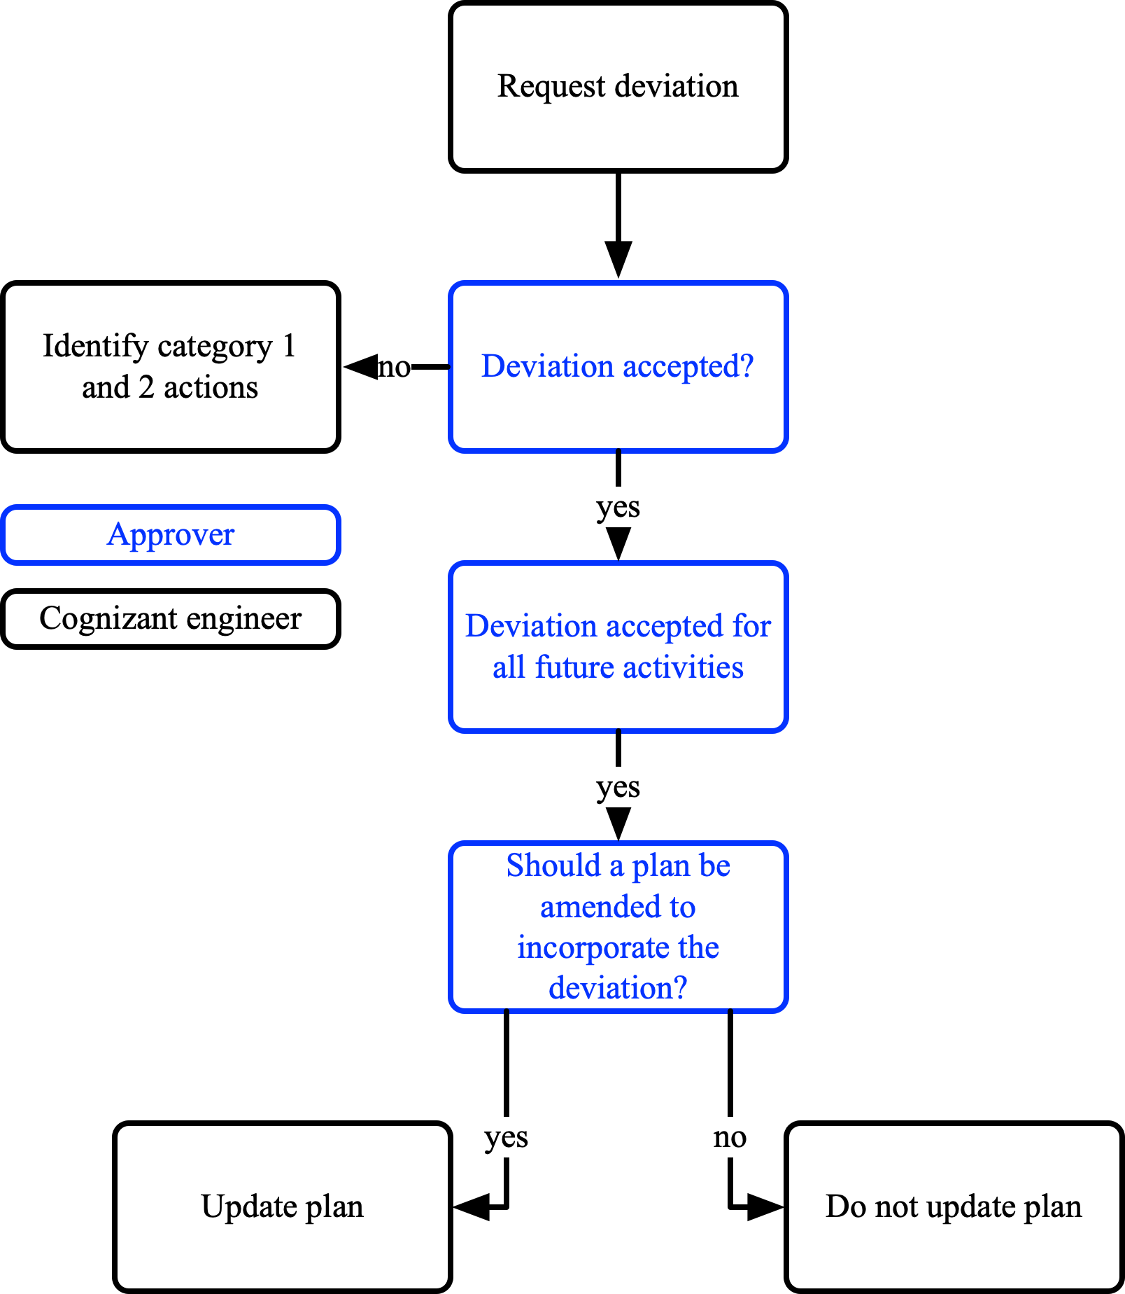
Figure 5-1: Deviation States

Process Assurance Checklist
Checklists shall evaluate and include at a minimum the following:
- The content of plans (configuration management, development, process assurance, validation and verification) are consistent with the Functional Development Assurance Level (FDAL) of all functions that are assigned to the system/ sub-system
NOTE: If functions of different severities are assigned to the system/ sub-system, the most severe function determines the FDAL of the system/ sub-system
- The Program Plan is consistent with and allocates sufficient resources for timely initial/ final versions and updates of plans
- The engineering lifecycle plans are consistent with each other
- The engineering lifecycle plans minimise repetition
- Evidence that sufficient coordination externally, including with the regulatory authority, is planned
- Evidence that sufficient coordination internally is planned
- Evidence that plans have been informally/ formally peer reviewed and approved
- Evidence of plan initial/ final versions and updates
- Evidence that requirements plans, including requirements correctness and completeness checks, have been executed

Process Assurance Lifeycle

General
Technical reviews at a minimum will be completed at the following major program milestones:
- Concept Design Review (CoDR)
- System Requirements Review (SRR)
- Preliminary Design Review (PDR)
- Critical Design Review (CDR)
- Test Readiness Review(s) (TRR)
- First Flight Readiness Review (FFRR)
- Type Inspection Review (TIR)
- Production Readiness Review (PRR)
The PDR and CDR are conducted at system and sub-system levels and by the supplier for the equipment provided.

CoDR Deliverables
The process assurance deliverables for CoDR are the following:
- Initial peer reviewed/ approved Development Plan

SRR Deliverables
The process assurance deliverables for SRR are the following:
- Initial peer reviewed Process Assurance Plan
- Initial peer reviewed Validation and Verification Plan
- Initial peer reviewed Configuration Management Plan
- Final peer reviewed/ approved Development Plan

PDR Deliverables
The process assurance deliverables for PDR are the following:
- Final peer reviewed/ approved Process Assurance Plan
  - Process assurance checklists
- Final peer reviewed/ approved Validation and Verification Plan
- Final peer reviewed/ approved Configuration Management Plan
- PDR updated Development Plan
- Initial peer reviewed Certification Plan(s)
- Audit for conformance to plans

CDR Deliverables
The process assurance deliverables for CDR are the following:
- CDR updated peer reviewed Process Assurance Plan
  - Process assurance checklists
- CDR updated peer reviewed Validation and Verification Plan
- CDR updated peer reviewed Configuration Management Plan
- CDR updated peer reviewed Development Plan
- Final certification authority approved Certification Plan(s)
- Audit for conformance to plans

FFRR Deliverables
The process assurance deliverables for FFRR are the following:
- SoF process assurance evidence/ data
  - Process assurance checklist evidence/ data
- SoF validation and verification evidence/ data
  - Validation evidence including requirements correctness and completeness checks
  - Verification evidence/ data
- SoF configuration management evidence/ data
- SoF development evidence/ data
- Audit for conformance to plans
NOTE: Non-conformances to plans should be reviewed for impact on SoF
NOTE 1: A deviation is not considered a non-conformance if it has been approved through the deviation process

TC Deliverables
The process assurance deliverables for TC are the following:
- Final process assurance evidence/ data
  - Process assurance checklist evidence/ data
- Final validation and verification evidence/ data
  - Validation evidence including requirements correctness and completeness checks
  - Verification evidence/ data
  - Compliance evidence/ data
- Final configuration management evidence/ data
- Final development evidence/ data
- Audit for conformance to plans
NOTE: Non-conformances to plans should be reviewed for impact on TC
NOTE 1: A deviation is not considered a non-conformance if it has been approved through the deviation process

Templates and Checklists

Process Assurance Checklist
# | Process Assurance Check
1 | Are the plans consistent?
2 | Have the plans been peer reviewed and approved according to the schedule in the Process Assurance Plan?
3 | Have the plans been peer reviewed and approved according to the schedule in the Validation and Verification Plan?
4 | Are minutes available from major program milestone reviews and are category 1 and 2 actions being appropriately dispositioned?
5 | Are minutes available from Engineering Review Boards (ERBs)?
6 | Have plans been updated to reflect changes and are changes being appropriately tracked and communicated to stakeholders?
7 | Are plan non-conformances tracked?
8 | Have previous non-conformities been satisfactorily addressed are accepted and recorded via the deviation review process
9 | Are plan deviations tracked?
10 | Have previous deviations been accepted and recorded via the deviation review process
11 | Are archived records from design, requirements, validation, verification activities being generated in accordance with the plans?
12 | Is evidence and archived records of problem reporting available?
13 | Is evidence and archived records of change control available?
14 | Are communication practices necessary for the execution of tasks in accordance with the plans in place?
Table 9-1: Process Assurance Checklist

